Building the FPGA Board V2 by D. Keekstra

Before starting soldering on the real board it’s better to do some testing. For the testing there is an PCB attached to the board with all kinds of footprints. Don’t hesitate to try some before starting. This tutorial is a guide for soldering the board but doesn’t guaranty correctness.

# Recommended tools

Before starting to solder be sure to have the correct tools with you. Beneath you will find a list with recommend tools for making the board.

|  |  |
| --- | --- |
| Flux |  |
| Solder pump |  |
| Wire cutters |  |
| Tweezers |  |
| Old toothbrush |  |
| Flux Remover |  |
| Soldering iron  with a medium or small tip  Thin tin for a good dosage. |  |
| Tip Cleaner |  |
| Solder wick | Image result for solder wick |
| Third hand |  |
| Magnifying glasses or a microscope |  |

# ESD Safety

To prevent parts from breaking by electric shocks be sure to take ESD measures. Although the most parts are not extremely sensitive for ESD it is recommended to take ESD measures like a antistatic wristband or/and a grounded mat for soldering the board.

# Soldering techniques

For soldering the footprints with a lot of pins (FPGA, microcontroller, etc.) it’s recommended to use the following solder technique:

1. Start by placing the IC at the correct place.
2. Solder one or two next to each other easy to reach pins to the board.
3. Now watch carefully if all pins are correctly aligned.
4. If not, heat up the soldered pins and move the chip with tweezers or your fingers (don’t heat up the pins to long or make them to hot!).
5. Check again if the chip is correctly aligned at all sides. In not repeat step 4 until it is.
6. When you are sure all pins are aligned solder one or two pins diagonal to the first soldered pin(s) so the chip is stuck to the board.
7. Now apply flux to a side of the chip where there are no soldered pins.
8. Apply a little solder tin to your iron and gently move over the pins. Don’t stop or break when a few pins are connected to each other! This will be fixed in step 10

The amount of tin applied is key for a good solder. Try not to use to much tin because this will short your pins to each other. If you use to less tin there will be bad connections. Try to get a feeling for it.

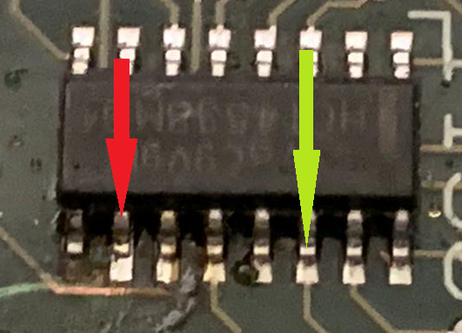

Figure : Red: to little tin, Geen: good amount

1. Repeat step 7 and 8 for the other sides. Be sure you take in to account that there is already tin applied to some pins for the alignment. You should apply less tin for these sides.
2. When there are a few pins are connected to each other you can first try to apply flux again and try to gently spread the tin to the other pins of the side.
3. If there is really to much tin try to move it to one side next you can lay solder wick on the pins and heat the solder wick with your iron. This will suck the tin away. Be careful when getting the wick of again. If its stuck first heat it again or you will break the pins!
4. When you used the solder wick be sure the pins have enough tin left. If not try to spread a little or apply a little again.
5. Always check you soldering’s with a magnifying glass or microscope.

For a video you can watch this tutorial on SMD chip soldering by EEVblog.

<https://www.youtube.com/watch?v=hoLf8gvvXXU>

For soldering components with only a few pins (capacitors, transistors etc.) the technique is slightly different.

1. Try to find the easiest to reach pin on the board.
2. Apply a little tin to the pad.
3. Get the component with a tweezer in one hand and aligned it while holding the solder iron in the other hand.
4. Now heat the tinned pad and solder the pin of the component while holding it in place with your tweezer.
5. If it is correctly aligned move the iron and keep the component in place when the tin is cooling.
6. Now the other pins can be soldered one by one.
7. For some packages it can be handy to use flux when pins are connected to each other.

# Components list

DO NOT solder the components in this order!

|  |  |  |  |  |
| --- | --- | --- | --- | --- |
| Type | Qty | Value | Package | Parts |
| Capacitor | 33 | 100nF | C0603 | C1, C2, C3, C5, C7, C8, C11, C13, C17, C27, C28, C29, C30, C31, C32, C33, C34, C35, C36, C37, C38, C39, C40, C44,  C45, C46, C47, C58, C59, C60, C61, C64, C65 |
|  | 4 | 16pF | C0603 | C4, C6, C81, C82 |
|  | 4 | 22pF | C0603 | C9, C12, C23, C49 |
|  | 22 | 10uF X5R | C0805K | C10, C14, C15, C16, C18, C20, C22, C24, C25, C26, C41, C42, C43, C50, C51, C52, C53, C54, C55, C78, C79, C80 |
|  |  |  |  |  |
| Cap Pol | 1 | 330uF | D/7343-31W | C21 |
|  |  |  |  |  |
| Resistor | 1 | 100R | R0603 | R35 |
|  | 2 | 10 | R0603 | R21, R22 |
|  | 8 | 10k | R0603 | R5, R11, R18, R24, R25, R33, R34, R36 |
|  | 2 | 100k | R0603 | R28, R29 |
|  | 2 | 1k | R0603 | R8, R17 |
|  | 1 | 200R | R0603 | R6 |
|  | 1 | 150k | R0603 | R19 |
|  | 1 | 120R | R0603 | R23 |
|  | 1 | 32k | R0603 | R2 |
|  | 1 | 33k | R0603 | R20 |
|  | 2 | 2k2 | R0603 | R26, R27 |
|  | 4 | 0 | R0603 | R1, R3, R4, R12 |
|  |  |  |  |  |
| Res Array | 5 | 1k | 744-8NS | RN1, RN3, RN5, RN6, RN7 |
|  | 2 | 10k | 744-8NS | RN2, RN13 |
|  |  |  |  |  |
| Ferrite Beads | 6 | B-EU | C0603 | B1, B2, B3, B4, B5, B6 |
|  |  |  |  |  |
| Coil | 3 | 3.3uH 1.9A PWR | SLF7032T | L2, L3, L4 |
|  |  |  |  |  |
| Xtal | 1 | 12MHz | QS | Q1 |
|  | 1 | 25MHz | QS | Q2 |
|  |  |  |  |  |
| Mosfet | 1 | NTR2101P | SOT23-3 | Q3 |
|  |  |  |  |  |
| TVS | 1 | Bi TVS 5V | SOD-523 | D1 |
|  | 2 | IP4234CZ6,125 | SOT95-6N | D2, D3 |
|  |  |  |  |  |
| Leds | 1 | OVSTRGBBCR8 | 150505M173300 | LED9 |
|  | 9 | Any color | CHIP-LED0805 | LED0, LED1, LED2, LED3, LED4, LED5, LED6, LED7, USB_BLASTER |
|  |  |  |  |  |
| Headers | 1 |  | 1X02 | JP2 |
|  | 1 | GPIO Header | MA20-2 | SV1 |
|  | 1 | Pickit2 | MA06-1 | SV3 |
|  | 1 | VIN | JST-2-PTH-VERT | JP1 |
|  |  |  |  |  |
| Switches | 5 | DTSM-6 | DTSM-6 | RESET, S1, S2, S3, S4 |
|  | 1 | SWS004 | SMS-004 | S6 |
|  |  |  |  |  |
| Connectors | 1 | Screw terminal 3p | W237-3E | RS485 |
|  | 2 | MINI-USB | 32005-201 | X2, X3 |
|  | 1 | HDMI | HDMI_A | U$9 |
|  |  |  |  |  |
| IC's | 1 | OSCILLATOR 5X3 | 5X3 | U2 |
|  | 1 | SI5351A | MSOP-10 | U1 |
|  | 1 | 10CL016YE144C8G | QFP144 | IC1 |
|  | 3 | AP3429 | TSOT-25 | U$3, U$7, U$11 |
|  | 1 | IS25LQ040B-JNLE | SOIC8 | U4 |
|  | 1 | Any 3.3v rs485 | SO-08 | IC2 |
|  | 1 | PIC18F14K50-I/SS | SOP20 | U3 |
|  |  |  |  |  |
|  |  |  |  |  |
| Misc | 1 | PCB |  |  |
|  | 1 | USB Cable |  |  |
|  | 5 | Bumper |  |  |

# Soldering the actual board

When soldering the board be sure to check your soldering’s. Especially the big chips with small outlines. Its recommended to check all connections of these chips under the microscope or magnifying glasses.

1. Solder the SI5351A Clock chip

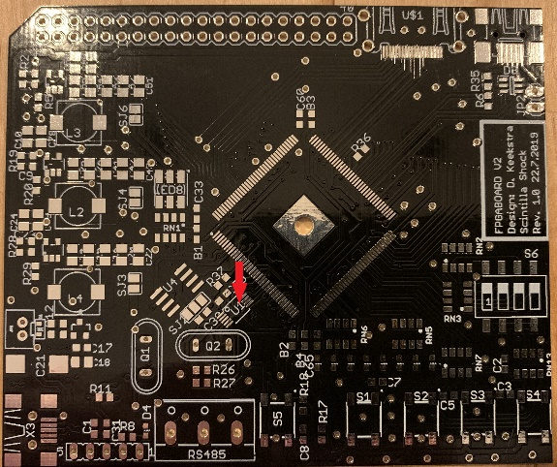

1. Solder the FPGA (be aware of the marking)

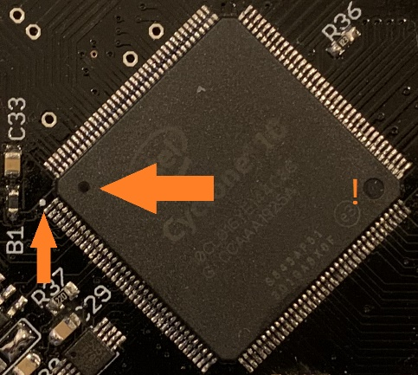

1. Solder the memory chip IS25LQ040B-JNLE

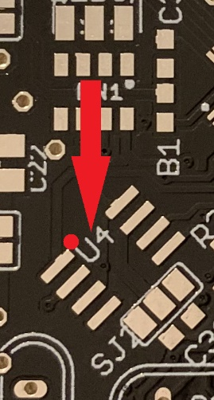

1. Solder the RGB led. Place the led with the corner to the dot on the PCB

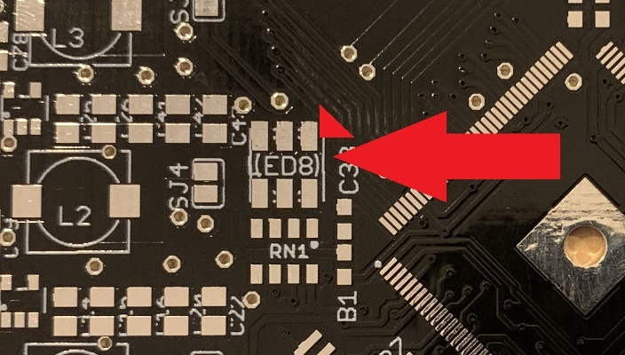

1. Place 3x buck converter AP3429

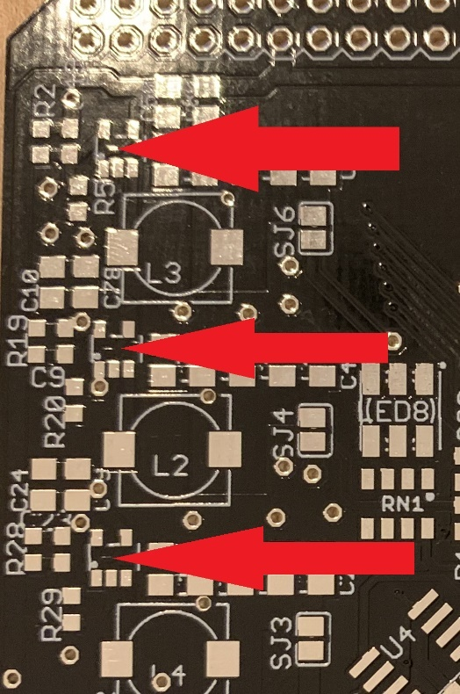

1. Place the mosfet NTR2101P

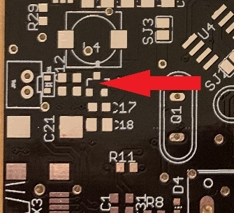

1. Place diode D1 Bi TVS 5V (polarity doesn’t matter)

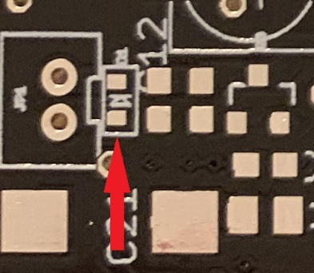

1. Place the 1K resistor arrays

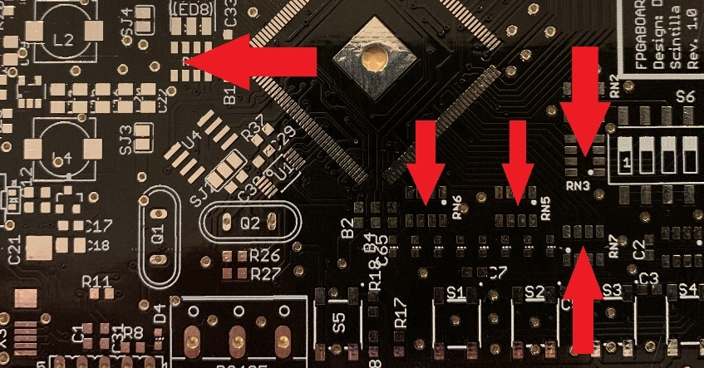

1. Place the 10K resistor arrays

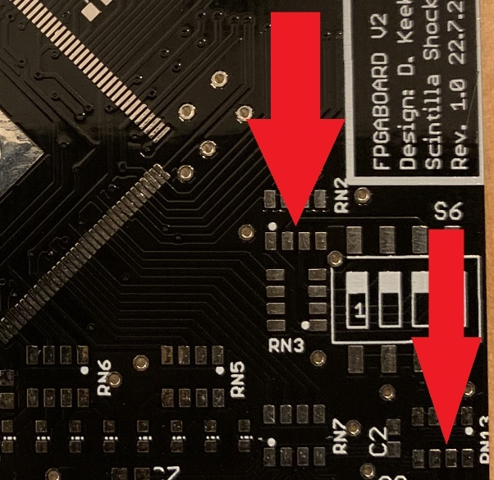

1. Place 4x Ferrite beads (only on top)

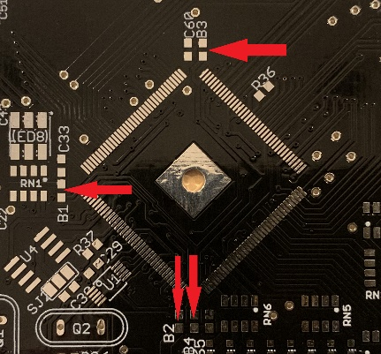

1. Place 9x leds

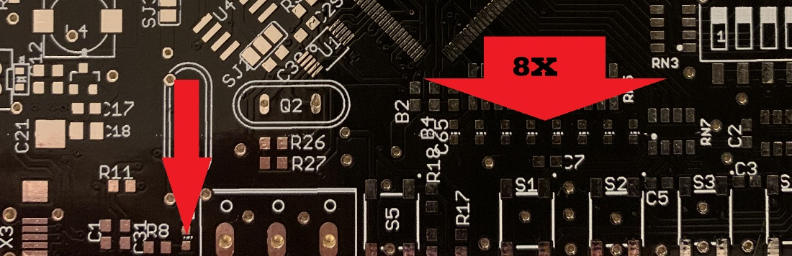

1. Place all the resistors at top level (marked on the PCB)

|  |  |  |  |
| --- | --- | --- | --- |
| 1 | 100R | R0603 | R35 |
| 4 | 10k | R0603 | R5, R11, R18, R36 |
| 2 | 100k | R0603 | R28, R29 |
| 2 | 1k | R0603 | R8, R17 |
| 1 | 200R | R0603 | R6 |
| 1 | 150k | R0603 | R19 |
| 1 | 32k | R0603 | R2 |
| 1 | 33k | R0603 | R20 |
| 2 | 2k2 | R0603 | R26, R27 |

1. Place 4x 22pF’s

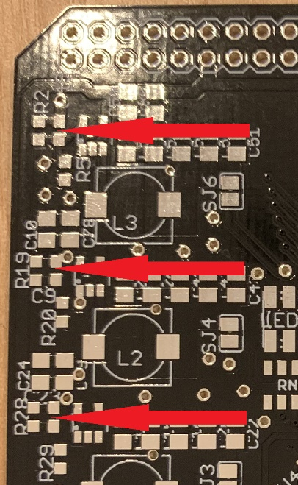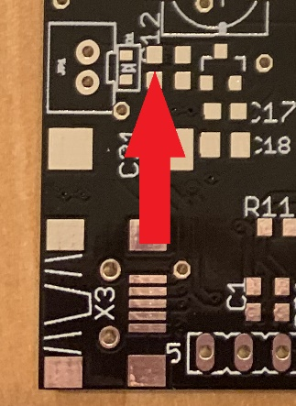

1. Place the polarized capacitor

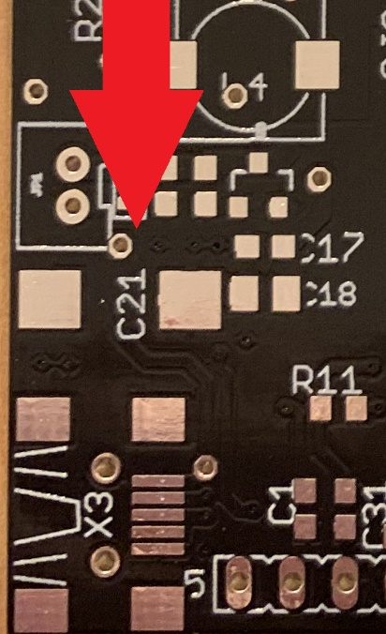

1. Place 22x 10uF’s

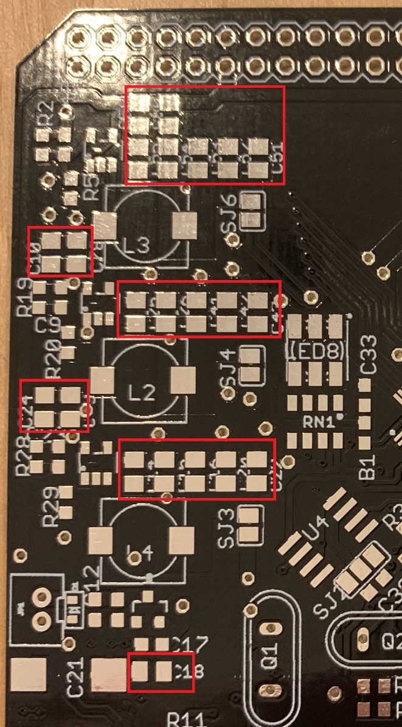

1. Place the 100nF’s only at top level (All 0603 footprints that aren’t soldered yet)
2. Place the two USB connectors

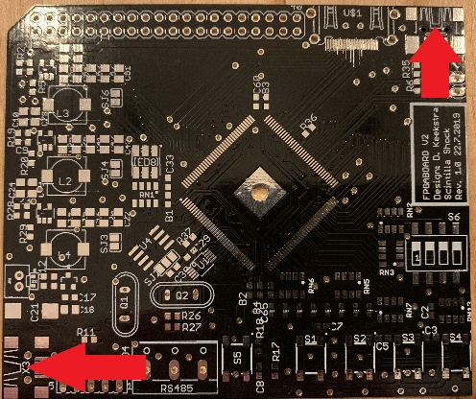

1. Place TVS Diode D3 IP4234CZ6,125

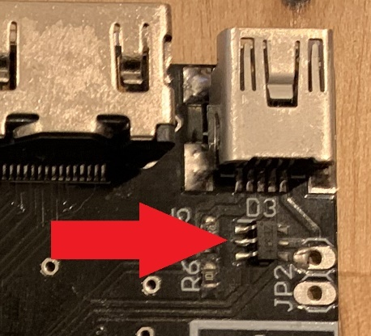

1. Place 3x Coils SLF7032T

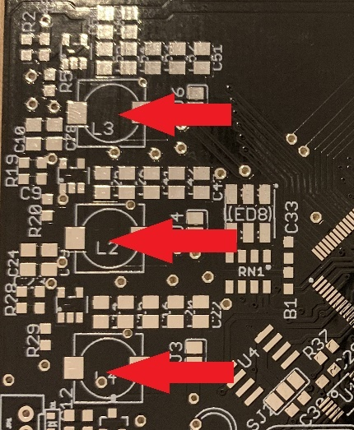

1. Place 5x button

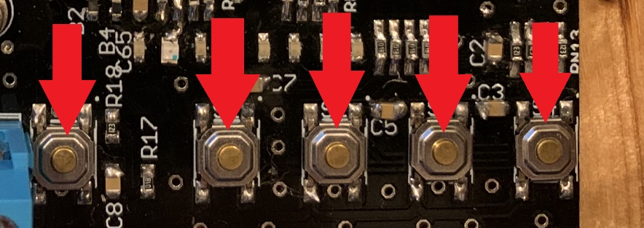

1. Place the dipswitch

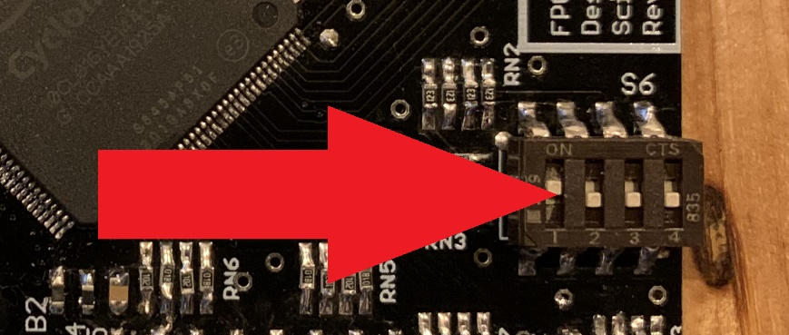

1. Now turn the PCB upside down
2. Solder the Microcontroller PIC18F14K50-I/SS

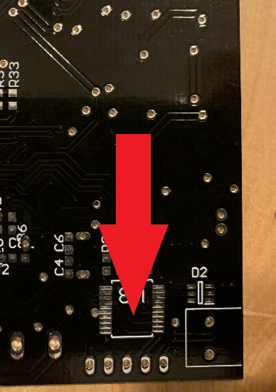

1. Program the microcontroller (Don’t skip this step when d2 is soldered you can’t program it anymore!)

The programming can be done by a pickit 2 or different programmer on SV1

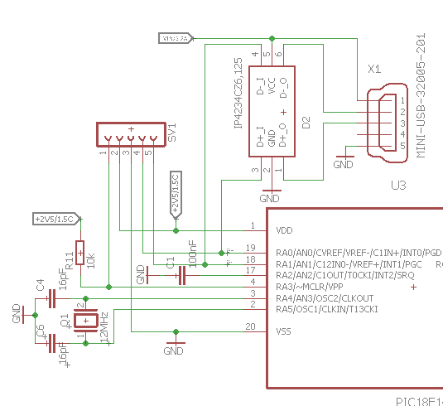

1. Place 4x 16pF

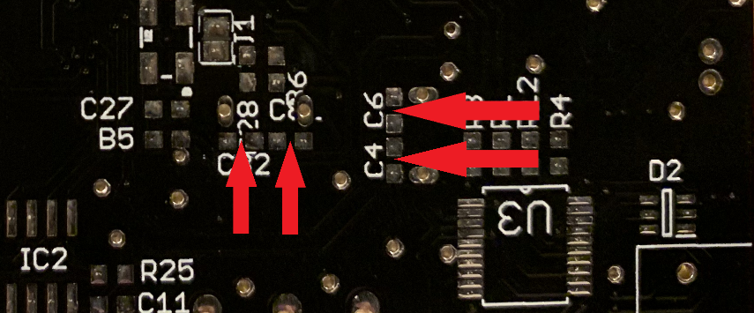

1. Place the oscillator

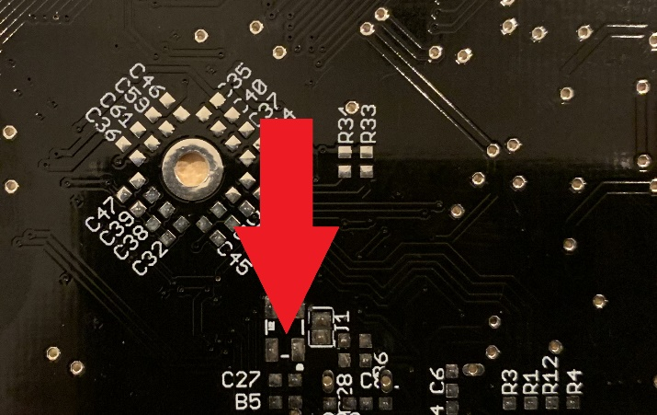

1. Place the differential bus converter (look at the side for the correct position)

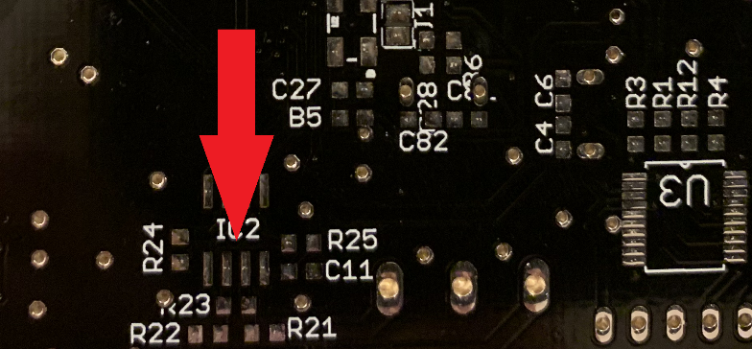

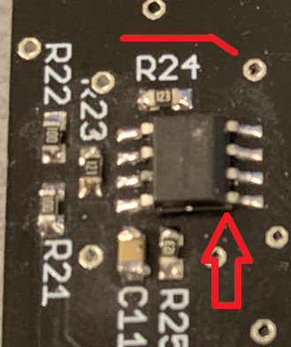

1. Place the resistors on bottom level

|  |  |  |  |
| --- | --- | --- | --- |
| 2 | 10 | R0603 | R21, R22 |
| 4 | 10k | R0603 | R24, R25, R33, R34 |
| 1 | 120R | R0603 | R23 |
| 4 | 0 | R0603 | R1, R3, R4, R12 |

1. Place D2 IP4234CZ6,125

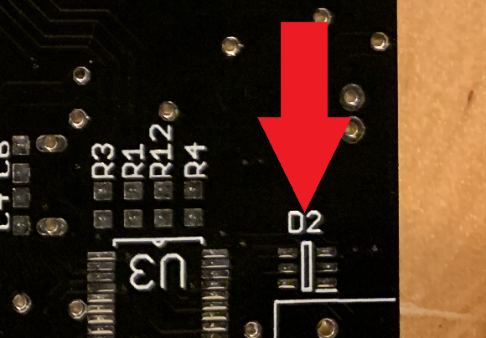

1. Place all the 100nf at the bottom (the only 0603 packages left)
2. Place the HDMI connector

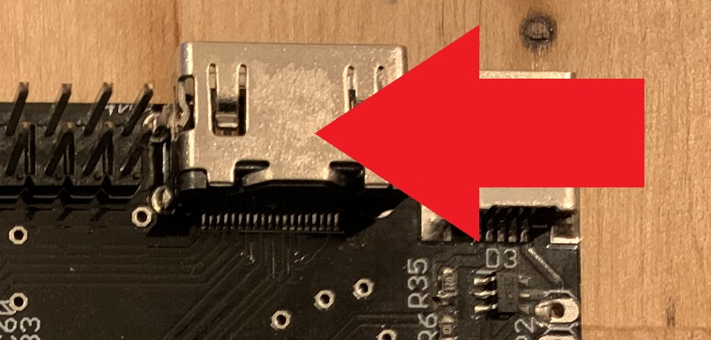

1. Place Xtal Q1 12Mhz

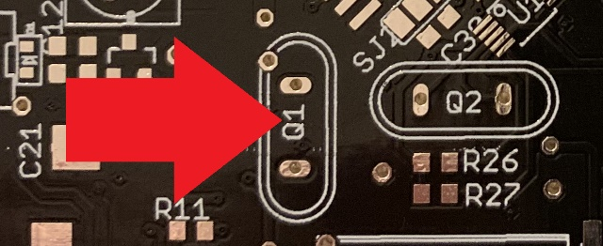

1. Place Xtal Q2 25Mhz

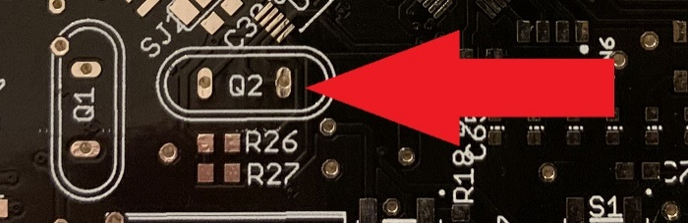

1. Solder the tow ferrite beads B5 and B6 on the back side.
2. Place the screw terminal

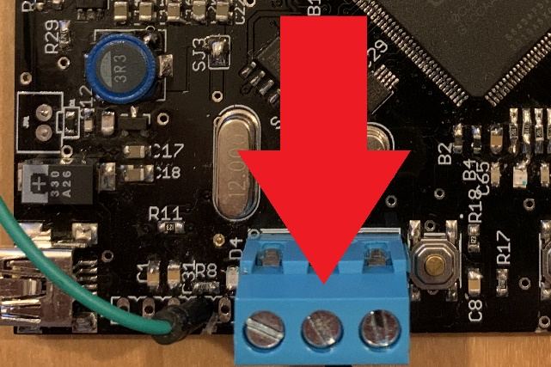

1. Place the 40-pins terminal

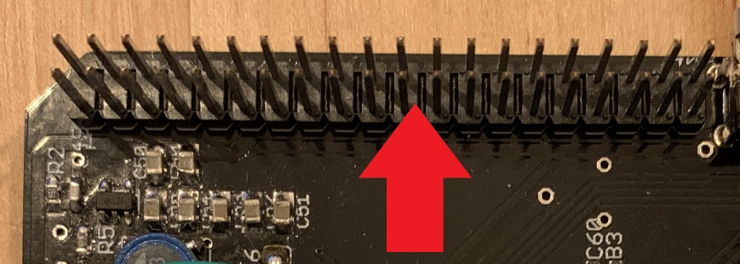

1. When you’re done with chapter 6 you can glue the bumpers to the bottom of the board to protect the contacts from hitting the surface.
2. You only need resistor R37 this can be 100-220 ohm 0603 resistor and can be collected at the stores.

# Checking/Measuring

For the measuring you can use a simple multimeter.

1. Short test

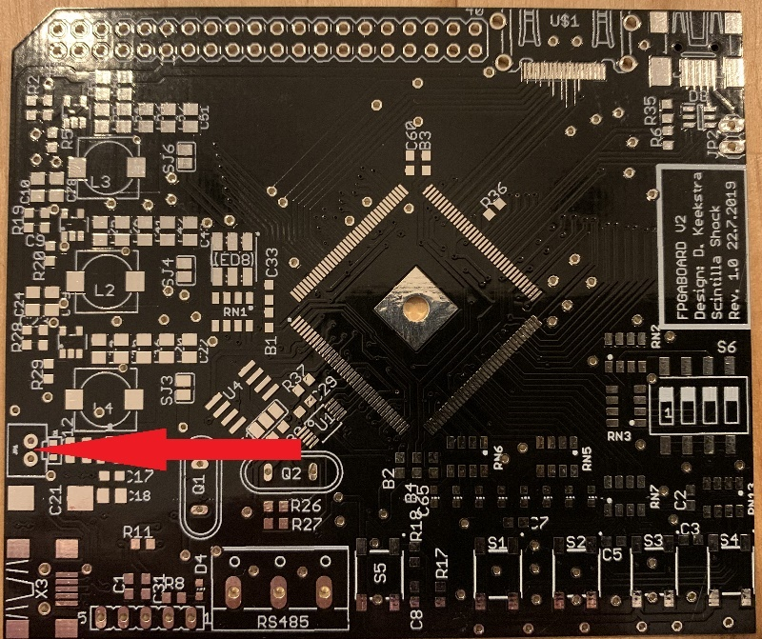

Measure on JP1 if there exist any short. A normal value should be between 100k and 500k ohm.

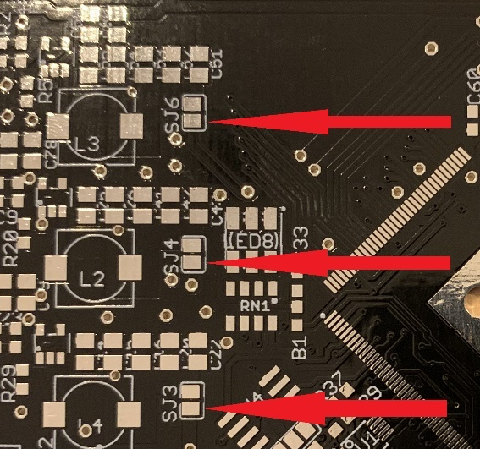Measure if there exist any shorts to ground from the bottom side of SJ6, SJ4 and SJ3 (see the picture). If there is a short remove the short before going any further!

1. Current

Connect the board to a proper lab power supply first (don’t try it on your laptop you may have a chance to break it!). The board should take max 10mA.

1. 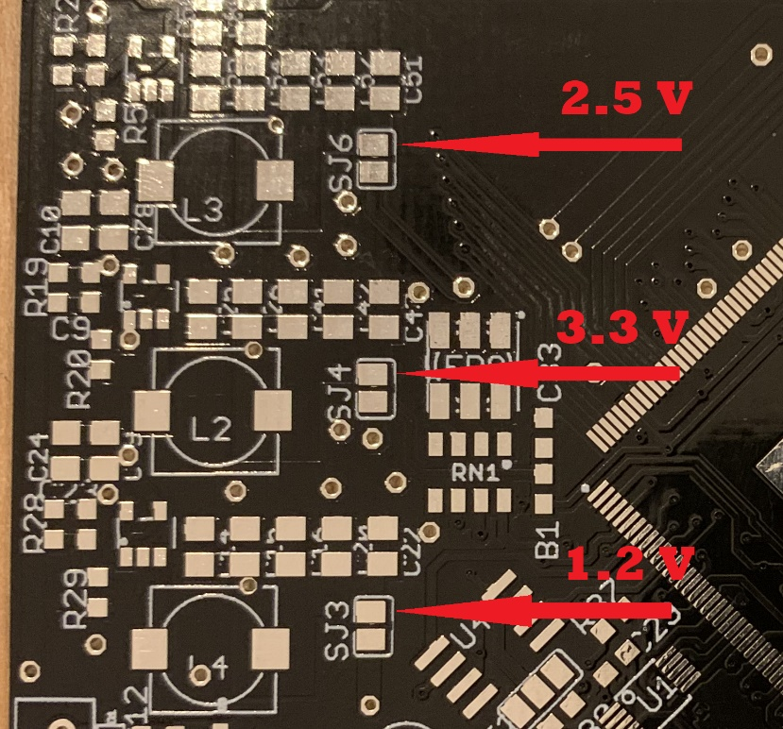Voltages

There are three power supplies on the boards. The voltages can be measured on the solder jumpers as shown on the picture. The voltages should be maximum 100mV off. When they all measure the correct values power off the board and make shorts on the three solder jumpers SJ6, SJ4 and SJ3.

Now power up the board again with the lab power supply and check step 2 again.

When this is done check the voltages again. When everything is correct you can try to program the demo software.

